**Annual Report of the Tarporley Parochial Church Council and Accounts for the Year Ended 31st December 2023**

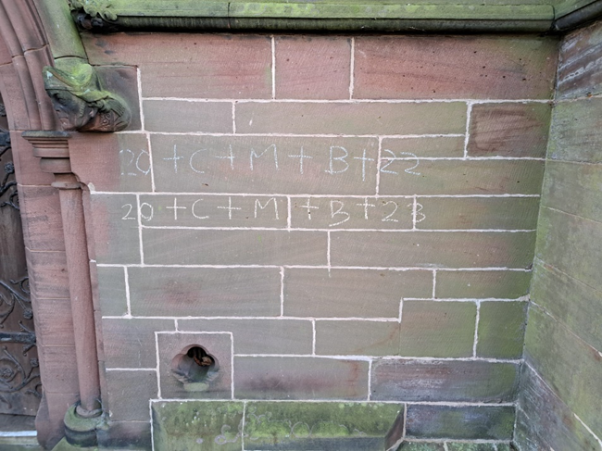

***Praying for God’s blessing on the parish for the year ahead at Epiphany***

**Annual Report of the Tarporley Parochial Church Council and Accounts for the Year Ended 31st December 2023**

What follows is a brief report of our Parish life in 2023.

Once again, it was a full year, with plenty going on and signs of God’s work among us. There is much to be thankful for, as well as lots to continue to pray for.

My thanks go to clergy colleagues who helped sustain and enhance ministry and mission in the parish during the year - Revd Trevor Davies, Revd Jenny Bridgman and Revd Richard Tuckwell – as well as Church Wardens and officers and members of our PCC for their unstinting hard work and complete support.

One of the words that really struck home in 2023 was ‘gongoozler’, a canal phrase for those who stand on the cut and offer advice or criticism whilst never actually getting involved. In 2023, it was pleasing to see that this parish is the antithesis of the gongoozler: instead, so many people were willing to roll up their sleeves, get involved and put their faith into practice. So thank you to all those who have resisted the temptation to gongoozle!!

I hope that you will join with me to take encouragement from this report as evidence of God’s love and blessing unfolding in Tarporley, Eaton, Cotebrook, Rushton and Utkinton.

With every blessing

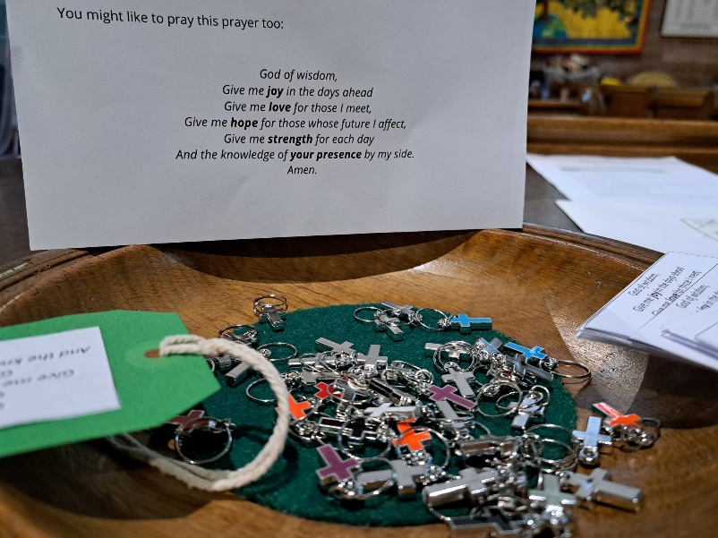*Jim*

Revd. Jim Bridgman

Rector of Tarporley

***Cross key rings and luggage tags prayers given out in September as people started new adventures: new schools, classes or holidays, with a reminder of God going with them.***

**The Parochial Church Council**

**of the Ecclesiastical Parish of Tarporley**

**A Registered Charity: Number 1130496**

**Aim and Purposes**

St Helen’s Tarporley Parochial Church Council (PCC) has the responsibility of cooperating with the incumbent, in promoting in the ecclesiastical parish, the whole mission of the church, pastoral, evangelistic, social and ecumenical. The PCC is also responsible for the maintenance of the Parish’s three churches: St Helen’s Tarporley, St John and the Holy Cross Cotebrook and St Thomas, Eaton their attendant churchyards and The Done Room. In pursuing these aims and purposes the PCC has due regard to the Charity Commission’s concern for public benefit.

**Objectives and Activities**

The PCC is committed to enabling as many people as possible to worship at our churches. Our services are open to all, and we are committed to making and keeping our churches, both during and outside of worship, welcoming sacred spaces where people can encounter the presence of God, sanctuary from an often-stressful world and, if they wish it, a place in a welcoming and caring community. When planning our activities for the year, both our regular worship and our extra activities, we have considered the Charity Commission’s guidance on public benefit. We are open to all and actively encourage participation in our services and activities from all sections of the community believing as we do that every person is made in the image of God. We try to help each other grow in knowledge and love of God and his son, our Lord Jesus Christ, through our worship and prayer and discipleship activities believing that the good news of the gospel enriches and gives purpose and direction to life. And we try to follow this teaching and communicate God’s love for all people through our pastoral and outreach work.

**Achievements and Performance**

In autumn 2022, the parish vision process identified a number of priorities:

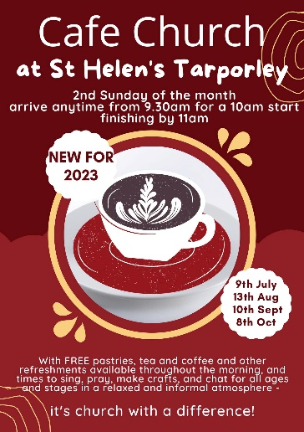a. Exploring a new pattern of worship.

b. Deepening prayer and discipleship.

c. Improving Facilities.

d. Engagement.

I. With communities.

II. With ‘un-churched’ people.

III. With schools.

**a. Exploring a new pattern of worship.**

A new pattern of worship was introduced from February 2023:

**1st Sunday of the Month**

9am Communion St Thomas’

10am Communion/Baptism St Helen’s

11.15am Communion St John’s

**2nd Sunday of the month**

9.30am Café Church St Helen’s/Done Room

4pm Communion St Thomas’

**3rd Sunday of the month**

9am Communion St Thomas’

10am Communion St Helen’s

[11.45am Baptisms at St Helens/St Thomas’]

6.30pm Evensong [4pm in winter] Alternates between all 3 churches

**4th Sunday of the month**

9am Songs of Praise – followed by Community brunch at the Jessie St Thomas’

10am Communion St Helen’s

4pm Messy Church Done Room

[11.45am Baptisms at St Helens/St Thomas’]

**5th Sunday of the month**

10am Joint Parish breakfast and service Alternates by each church with use of Jessie Hughes Hall/Done Room/Cotebrook Hall

[11.45am Baptisms at St Helens/St Thomas’]

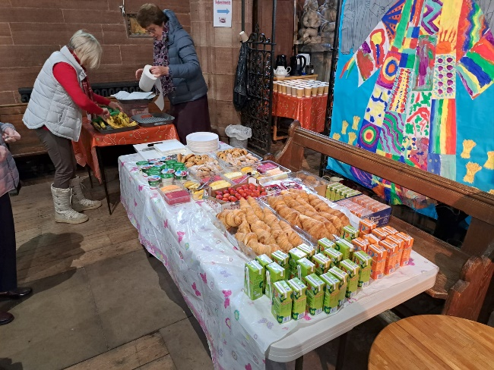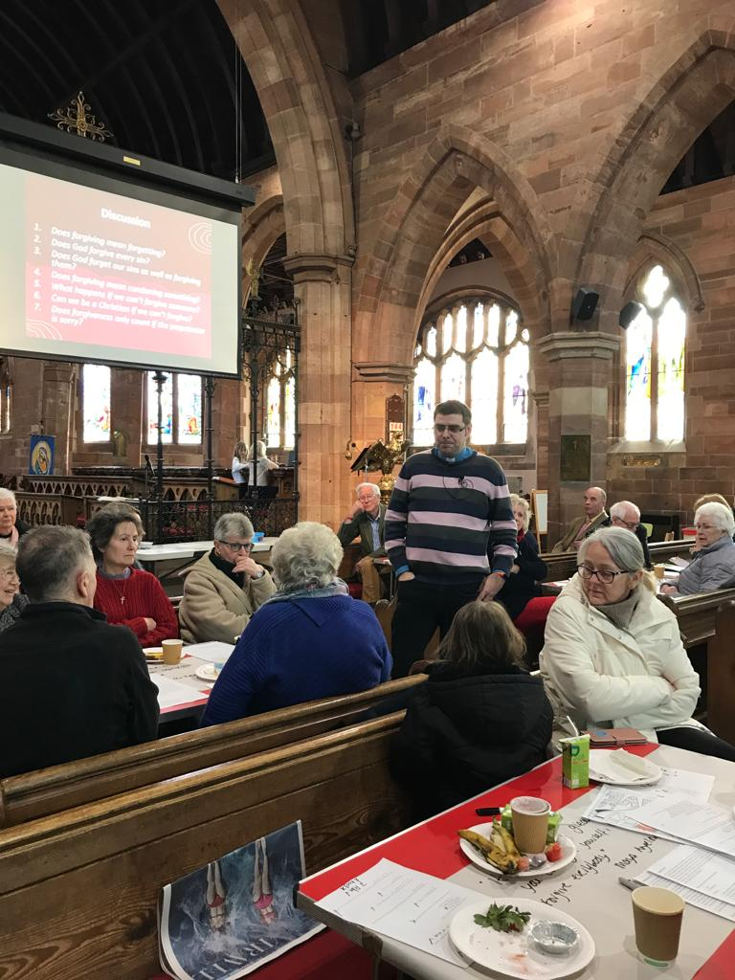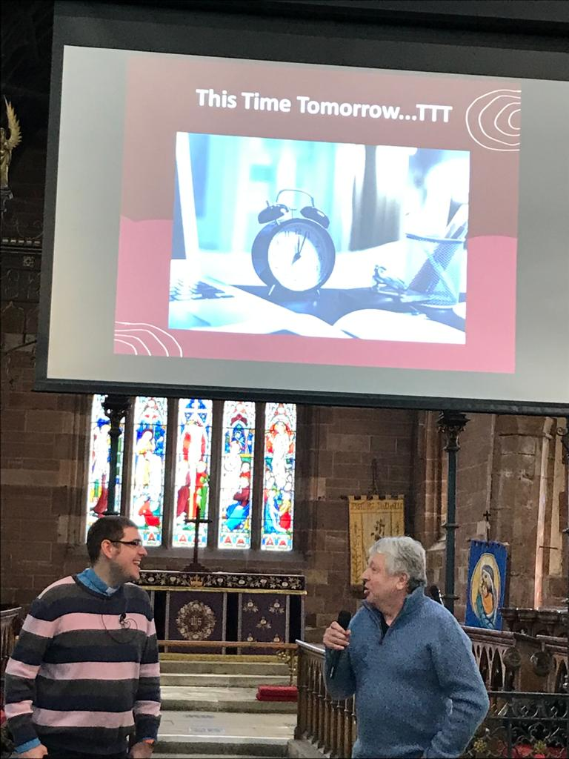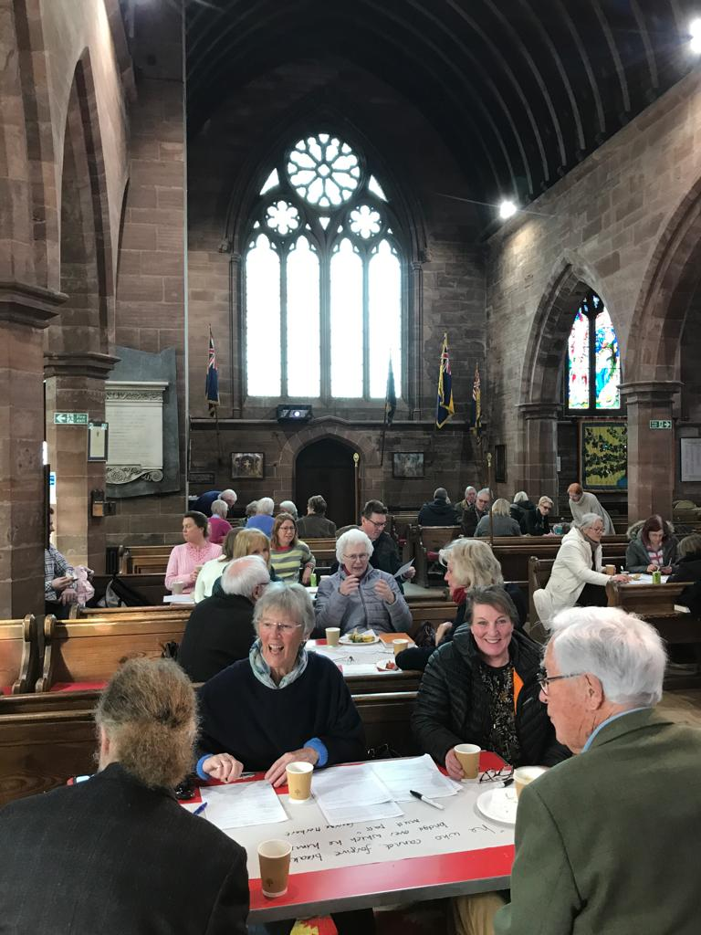The major changes were the introduction of two new services: Café Church on the second Sunday and Songs of Praise on the fourth Sunday. Café Church was billed as a joint parish service, with no other services in the parish that morning, an opportunity to worship altogether in a more informal, relaxed way, with plenty of refreshments. Pews were rearranged at St Helen’s to make a more café style atmosphere, and with plenty of food and drink available, each service had time for an opening quiz, times to sing, pray, and discuss with those around us. Over the course of the year, we considered topics such as Love, Forgiveness, Children and Communion, and Advent, as well as having a special service about the environment, with a speaker from the Christian conservation charity A Rocha. There has also been the chance to hear from congregation members about how their faith impacts their everyday life, in the monthly segment ‘This Time Tomorrow’, asking what they will be doing this time tomorrow. Café Church has been well received from families too, with the more relaxed atmosphere and food being a big hit.

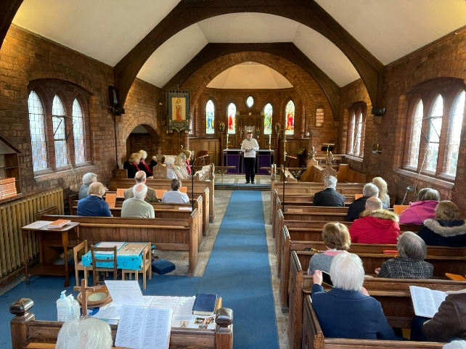

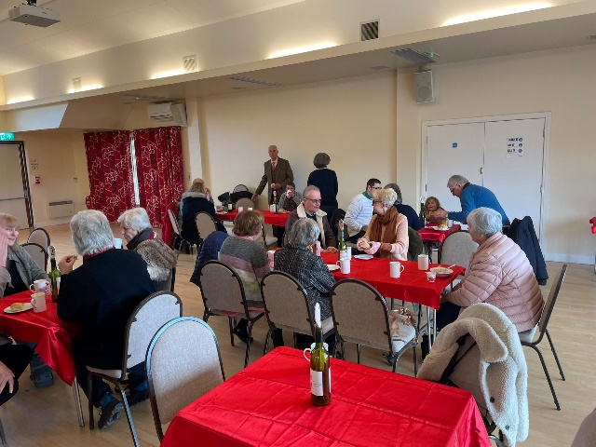Songs of Praise in Eaton on the fourth Sunday of the month has similarly been very well received. Each month a different congregation member chooses the music, hymns and readings that have been a part of their faith and life journey, and space is given to share where God has been a part of their life. Ably assisted by our organist, choir and the Eatonian music group, we’ve also heard music from the extremes: Elgar to Bruce Springsteen, Handel to Fleetwood Mac! It has often been emotional, and humbling to hear people’s experiences, and has helped us get to know one another better. Finishing with an excellent breakfast in the Jessie Hughes hall, it has now become the favourite Sunday of many people’s months.

Evensong moved to the third Sunday of the month, and was trialled moving around the churches, rather than being just at St Helen’s. In winter, it was also held at a slightly earlier time. Happily these changes allowed for others to be involved in Evensong, as well as encouraging those who have appreciated the liturgy at the end of the busy day. Additionally, on months with a fifth Sunday, we joined together for worship at one of the churches. This too has been an important part in breaking down barriers between congregations, getting familiar with different buildings, and making new friends across the parish. Thank you to everyone who has been brave enough to try something different in 2023, to move out of the comfort zone, to worship in another church or venue: mostly it has been a lot more pleasant than you feared, and you found that God is still there!!

Messy Church continued on the afternoon of the fourth Sundays of the month, looking at the themes of Jesus’s miracles and then some of the Heroes of the Old Testament, as well as seasonal sessions for Easter and Advent with the special guest helpers of Sandra and Charles Hardy helping to make chocolates (*pictured right*): unsurprisingly, these sessions were VERY well attended!! Messy Church continues to grow, with a good core of young people enjoying the crafts, games, worship songs and edible goodies each month. We are fortunate to have many connections with our children through the Done Room pre-school and our church schools. The team of helpers continues to produce wonders with paper, card, glue, icing sugar and biscuits, in addition to feeding all the children at the end of the session.

**b. Deepening prayer and discipleship.**

To compliment new styles of worship, there has also been a focus this year on deepening prayer and discipleship in the three churches, following Jesus in the ways we live as well as in deepening of our knowledge of God.

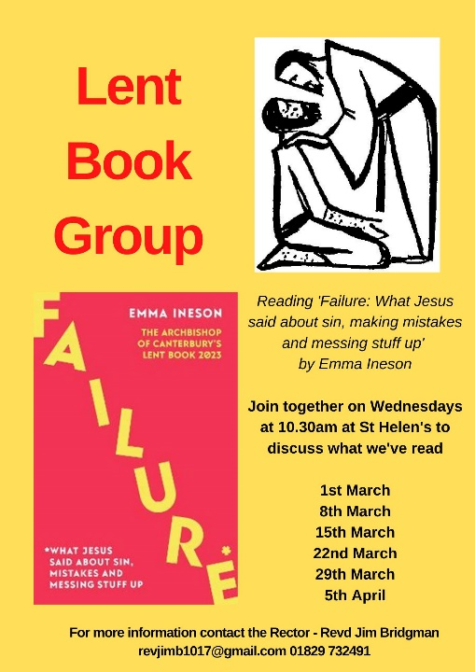

2023 saw a return of Lent and Advent book groups, focusing on ‘*Failure’* by Emma Ineson in Lent, and ‘*Stick with love’* by Arun Arora in Advent. Both books were stimulating and challenging, seeking to broaden our approaches to life and faith.

We continued to consider the impact that our lifestyles had on the world around us through the Eco Church initiative. Having gained a Bronze award for all three buildings at the start of 2023, the next goal was Silver, with the emphasis especially on engagement with individual lifestyle choices, encouraging congregation members to undertake carbon footprints and lifestyle surveys, and sharing practical tips for eco-friendly living. Walter Gibson and Nick Parker have also led the way in the creative use of our churchyards, with an ambitious seeding regime at St John’s, the introduction of bird boxes and benches at St Thomas’ and St John’s to encourage wildlife and the graveyards to be a place of recreation and space, as well as a differentiated approach to grass cutting. There is much still to do, and the introduction of some parish-wide policies on cleaning equipment, Fairtrade goods and light use will also help us in the quest for Silver.

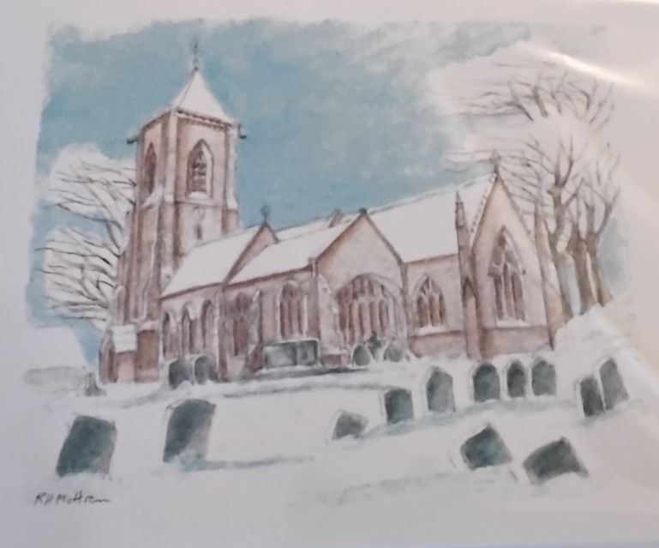There have also been opportunities for growth of discipleship with young people too, as PCC agreed to move forward with the Admission of Children to Communion before Confirmation, with a plan to prepare children in the spring of 2024. The travelling nativity (or ‘Posada’) in Advent proved so popular in 2022 that a second set travelled in the parish in 2023, one for families and one for adults, but both sets helped to prepare people for Christmas and led to some thoughtful reflections and conversations in the days of Advent. We also produced a lovely Christmas card for sale, using a fantastic drawing of St Helen’s by Roger Mottram (*pictured right*). Thanks to Kate O’Neill and the team for organising, packing and selling in church and the community!

**c. Improving Facilities.**

The main planning this year has revolved around the necessary work in the Done Room. In December 2022, the heating was replaced in the building. We also finally received faculty permission for the planned work to repair the gable ends, the roof, insert a fire escape and replace the front door. This work is hoped to be undertaken in the summer of 2024.

Outside of this, the three areas of improving facilities are the potential replacement of oil- fired heating at St Thomas' with an eco-friendly electric system, and toilets and small kitchens at both St Helen's and St Thomas'. These projects are still in the early planning stages, but hope to bring significant improvement for regular worshippers and visitors alike.

**d. Engagement.**

**I. With communities.**

One of the many positives of this parish is the role that each of the churches plays within their local community, and 2023 saw a continuation of that good work, being part of the heart of all things local. May saw the celebration and excitement of the coronation of King Charles III, with special services in each of the churches, as well as plenty of community events that we took part in – Revd Jim helped ‘crown’ two of the pupils from St Paul’s school at the Utkinton Coronation party (*pictured right*), and then led Grace with Revd Mark from the Chapel on the High Street in Tarporley before the street party, enjoyed in glorious sunshine.

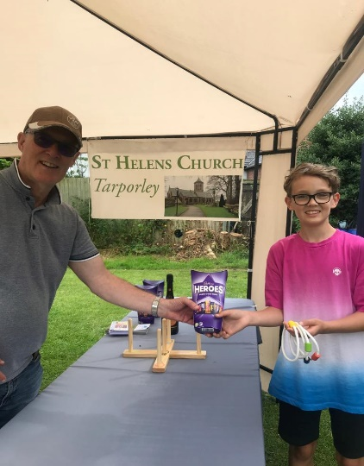In July, the parish had a stall at the Tarporley Carnival (*pictured right*) and (amid the torrential downpours!) offered games and a chance to talk to those at the event.

Working with parish councils has been a highlight of the year, cooperating in making our communities stronger and more connected. We have helped with Tarporley Parish Council in their Warm Spaces project, and being a space that received food from the Coop as part of the Zero Waste initiative. It was also good to have the first part of the new Art Trail unveiled outside St Helen’s, in addition to the revamped Tarporley village sign. A number of parishioners were involved in the Santa Dash at Christmas, and Revd Jim again helped to lead the Blessing of the Crib and Community carols with Revd Mark from Tarporley Chapel. In Utkinton, we worked with the parish council to support their Remembrance Day fundraising event at Rose Farm, and the council laid a Remembrance wreath at St John’s church too.

For the communities of Eaton and Rushton, the Jessie Hughes Hall is an important focal point, and in September there was a wonderful dedication of some beautiful stained glass windows and Memorial Rose Garden (*pictured above*) in memory of Her Majesty the late Queen. The windows were designed with the help of pupils at Eaton Primary, and produced by villager Gill Ellison. Both garden and windows were dedicated at a celebratory gathering by Revd Jim and are great additions to the front of the Hall.

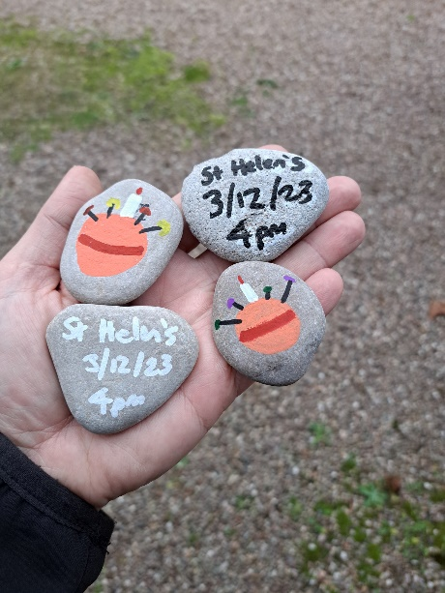During Advent and Christmas, carol singing in the community was a popular way of connecting and sharing the Christmas story, and this year we sang at The Alvanley Arms, on the green in Eaton, on the High Street in Tarporley on Christmas Eve, at Iddenshall Nursing home with residents and their families, and joined at The Dray’s as they celebrated a special event when the Posada (travelling nativity) stopped with Anne and Declan Kelly (*pictured right*). For Christingle this year, a number of painted rocks (*pictured left*) were placed on the High Street in Tarporley, with each rock found being swapped for a special gift at the service, an Advent Calendar.

There were a number of social events in the year to reach out to our communities: from the Afternoon Teas at the Done Room (*pictured below left*). which produced so much fun and entertainment, to the annual quizzes organised by both the Bell ringers’ and St Thomas’ church, to the one-man rendition of ‘A Christmas Carol’ at Cotebrook Village Hall, to the first of a number of planned presentations by local historian Maurice Hunt called ‘Tarporley Through Time’. We also had a great time celebrating one of our patron saints, St Thomas, in July, with a BBQ and social time at The Dray’s (*pictured below centre and right*). Thanks go to all those whose hard work, dedication and sacrifice meant that all these events were so successful and such good fun!

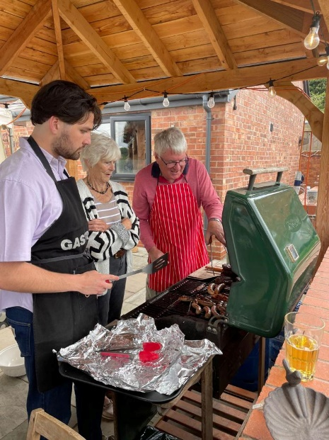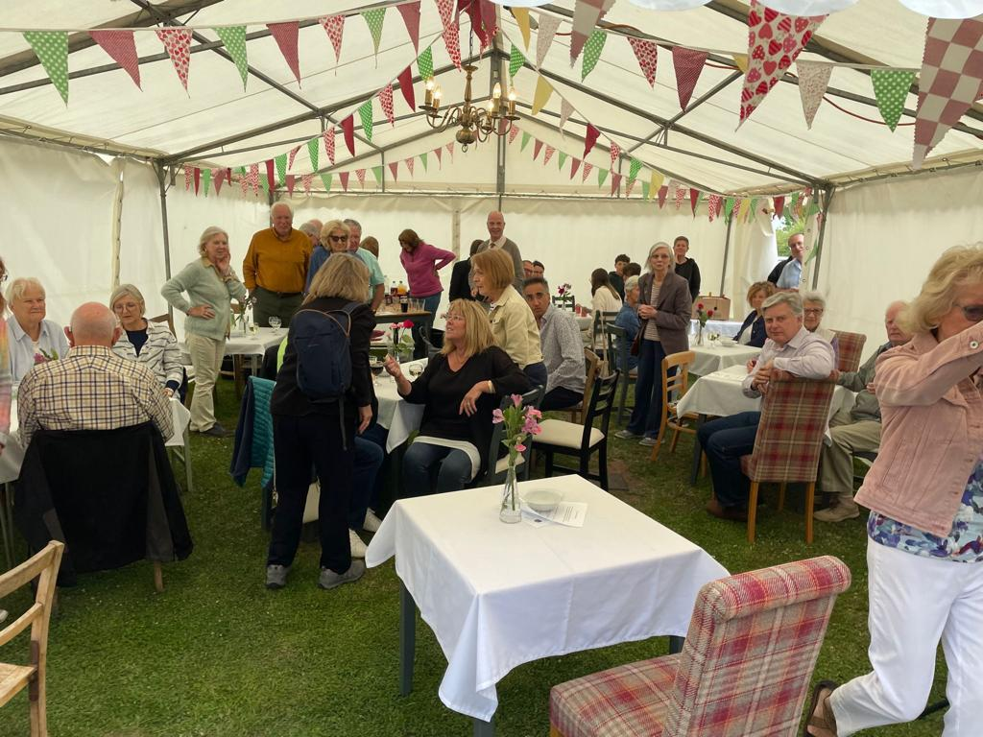

It has been an eventful year for the three churchyards too – as we have assessed our responsibility for our land through the Eco Church initiative, we began to think about how we use our churchyards, balancing a sense of respect and order, with a desire to be thoughtful and aware of our impact on the environment, and with an eye to the cost of the work. All three churchyards have assessed how often grass should be cut, and come up with churchyard plans for maintenance. A big thank you to the willing bands of volunteers at all three churches who have stepped up to the challenge, and will continue to monitor and care for the churchyards. During the year, we also received faculty permission for the introduction of a new memorial in St Helen’s to commemorate lives lost through stillbirth, abortion and miscarriage. This will be a place for people to gather and remember those who so often are not remembered elsewhere. This stone will be unveiled on Mothering Sunday 2024 by Bishop Mark, bishop of Chester.

The parish continues to support the Mid Cheshire Foodbank, with collection points in all three buildings, which are used throughout the year. We collected again for harvest, and during Advent offered a reverse Advent calendar to collect items for each day of Advent to give to the foodbank. Thank you for all your generous donations, and to those who organise delivery and collection of our donations.

*The Link* continues to keep the community updated with church life, in addition to the Facebook page and weekly email, sharing weekly readings and prayers and upcoming services and events from the three churches. Thanks to Andy Jobson for his sterling work on editing both the website and *The Link*, and his team of distributors for spread the news across the parish.

**II. With ‘un-churched’ people.**

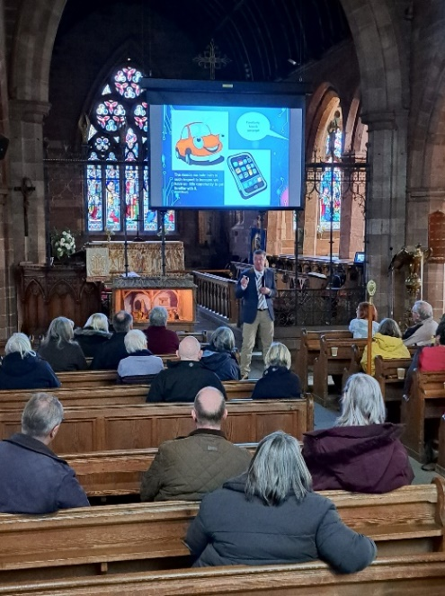Part of our mission to reach those within the community was the continuation of the Warm Space at St Helen’s on a Wednesday morning, offering a warm place, free refreshments and a chance to talk. During 2023, we also utilised the Warm Space time for a number of free talks (*pictured below*): we were grateful to hear from a diverse range of speakers, from Cyber security advice from Cheshire Police, the life and work of a local magistrate, Citizens Advice sharing with us how to save energy and keep warm during the cost of living crisis, and parishioners Martin and Fiona Buck sharing their work as Waterways Chaplains.

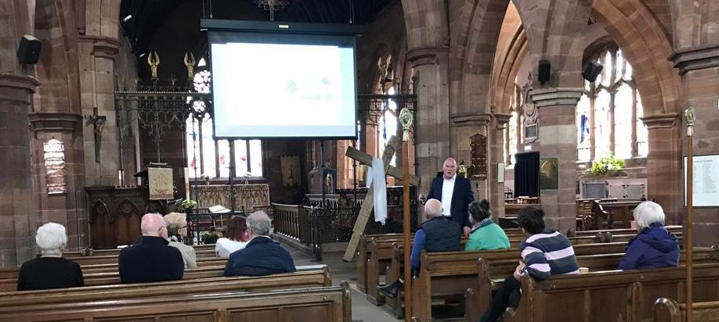

**III. With schools.**

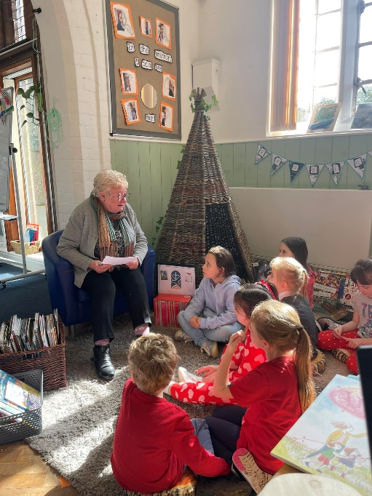We continue to be very grateful for the connections that we have with local schools, in particular our two church schools, Tarporley Primary School and St Paul’s Primary in Utkinton and Cotebrook. The parish continues to play a regular role in school life, with congregational representatives on both governing bodies, and groups of volunteers who have offered to listen to pupils reading at both schools (*pictured left*). Revd Jim continues to take Collective Worship fortnightly in both schools, and is now Vice-Chair of both Governing bodies. Both schools had inspections during 2023: St Paul’s had its Ofsted Inspection in the penultimate week of the summer term, and has seen great improvement in the school, earning it a ‘Good’ evaluation; Tarporley is waiting for its Ofsted, but in 2023 had a SIAMS inspection (Statutory Inspection of Anglican and Methodist Schools) which came out as ‘Excellent’. Both schools and their staff thoroughly deserve the outstanding achievements!

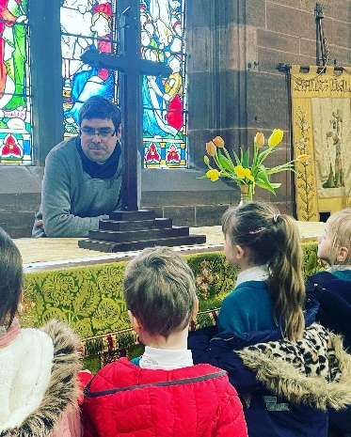St Helen’s continued to host a number of school events during the year, with Easter, Harvest, Christmas and Leavers’ services, and regular ‘Star of the Term’ Collective Worship for Tarporley Primary, who also held a musical showcase, exhibiting the musical talents of the pupils. Revd Jim continued to open church for school RE visits too (*pictured right*), exploring about weddings and baptisms, and the history of St Helen’s and its continued use and significance today. All of Year 7 of Tarporley High School once again visited in November as part of their joint history/geography field trip on the local area, and they returned at Christmas for another successful Christmas carol service. It has also been a joy to engage with Eaton Primary, visiting school for RE lessons. We have continued to support the Done Room Preschool too, and welcomed them for performance at St Helen’s at Easter, end of summer term, Harvest and Christmas.

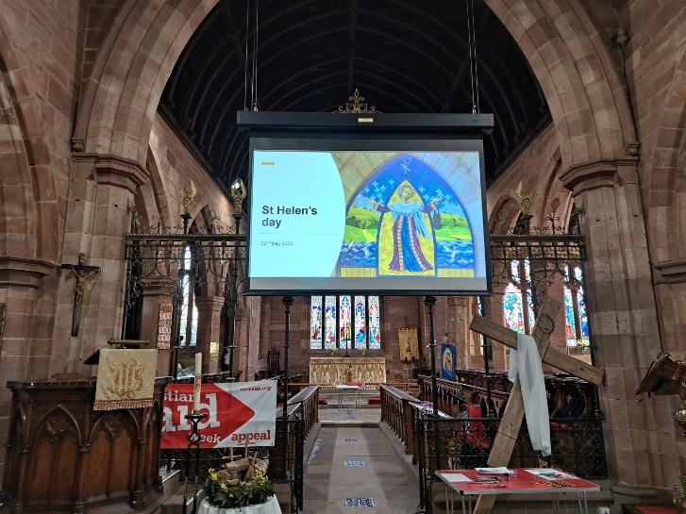

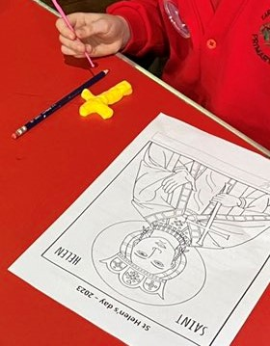A new venture for 2023 was a special celebration with Year 3 and 4 of Tarporley Primary on St Helen’s day. A group of volunteers and Revd Jim led three classes throughout the day in May, learning about the life of St Helen, and thinking about what saints are, and what St Helen can teach us about God’s role in our lives. There were quizzes to answer, Lego saints to make, and everyone went away with a special holding cross from clay to help them pray. Please continue to pray for the staff, pupils, governors and parents of our local schools.

**Pastoral Services and Activity**

The PCC recognizes that our ministry and churches offer a very important and unique resource at particular moments in people’s lives. It is a joy to be asked to baptise and marry people and share this celebration with family and friends and a privilege to be able to offer help and support to others through our funeral ministry. Rather than dictating the content of these services we work hard with all concerned to make sure that, within a Christian setting, they have a service that holds meaning for them. Such pastoral services mark important rites in everyone’s life and the Church extends the welcome and compassion of God to all people, regardless of their beliefs or background.

In addition to organizing and delivering the service itself the churches are involved in baptism and marriage preparation, helping families prepare for and organise funerals and following up with bereavement visits. Whilst the Clergy undertake most of this work they are supported and enormously helped by the Parish Pastoral Team formed of representatives from all our churches. The PCC also acknowledges the foundational importance of the informal visiting and pastoral care that takes place every day as members of our churches look out for and take care of each other and their neighbours and members of the wider community.

After the last few years of lockdowns and closures, all three churches had a full year of services.

|  |  |  |  |  |  |  |
| --- | --- | --- | --- | --- | --- | --- |
| **Church** | **Number of ‘usual’ Sunday**  **services** | **Usual Sunday Attendance\*** | **Baptisms** | **Weddings/**  **Renewal of Vows (RoV)** | **Funerals** | **Burial of Ashes** |
| St Helen’s | 38 | 57 adults (-1)  4 children (-1) | 10 (-5) | 6 (-2) | 19 (-) | 4 (-4) |
| St Thomas’ | 38 | 18 adults (-)  2 children (+2) | 2 (+1) | 0 (-1) | 2 (-) | 2 (+2) |
| St John’s | 13 | 15 adults (-4)  2 children (+2) | 0 (-1) | 1 (+1) | 1 (-) | 0 (-3) |

Change from 2022 (+/-)

|  |  |  |
| --- | --- | --- |
|  | Number of services | **Average**  **Attendance** |
| Joint services | 5 | 56 adults  1 child |
| Messy Church | 11 | 18 adults  19 children |
| Evensong | 10 | 11 adults |
| Café Church | 9 | 47 adults  10 children |
| Songs of Praise | 8 | 32 adults  3 children |

\**based on average over the year. This however does not reflect the extent of the ‘worshipping community’ (those connected with each church, and whose attendance may be irregular) which is higher.*

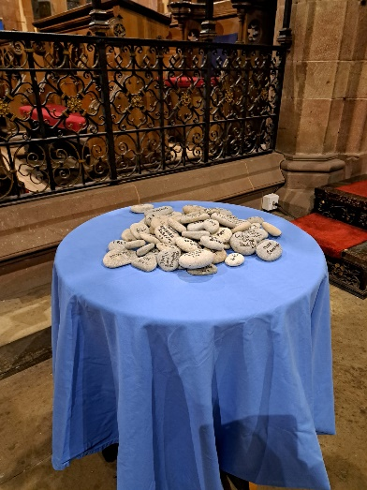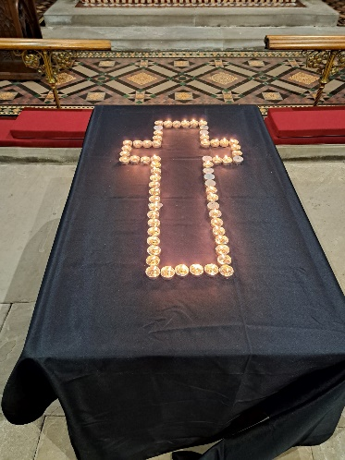

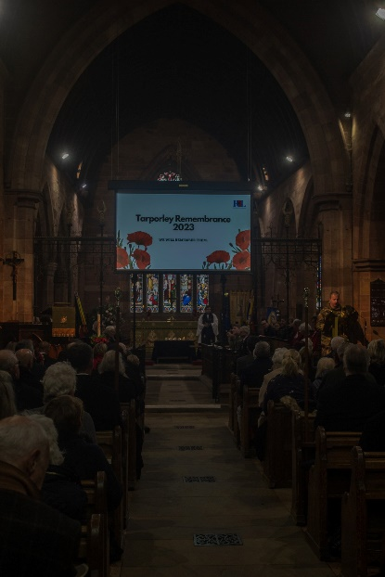In addition to regular Sunday and mid-week worship, we had usual special services to mark the Christian year. We held services throughout Holy Week and Easter, including a moving service on Good Friday based on *‘The Nail’* by Archbishop Stephen Cottrell; all three churches celebrated Harvest festivals (with a spectacular Harvest supper at St Thomas’); a special service for All Souls was held at St Helen’s for those bereaved during the year with an opportunity to light candles and build a cairn to remember loved ones (*pictured left and right*); Remembrance Sunday continued to be well attended, with an act of Remembrance at St Thomas, followed by the full parade in Tarporley, with all uniformed organisations joining us in church, where the focus was the 20th anniversary of the start of the Iraq war, where a number of veterans shared their reflections (*pictured below right*).

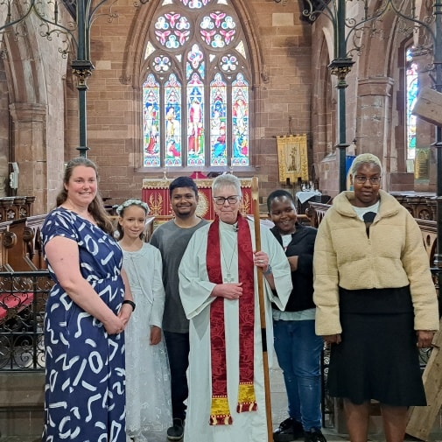

Bishop Julie, bishop of Birkenhead, came at Pentecost for a joint confirmation service held at St Helen’s (*pictured left*), and we also hosted this year’s World Day of Prayer, produced by sisters and brothers in Taiwan. During September, we also gathered at St Boniface in Bunbury for a special service to celebrate the work of Malpas Deanery, joining with friends from the local churches.

The Parochial Church Council

St Helen's Church, Tarporley

End of Year Financial Statements

Year ending 31st December 2023 and Independent Examiners report

# **Introduction**

Below are the accounts for the Parish of Tarporley which comprises of St Helen's Church, Tarporley, St Thomas', Eaton & St John & the Holy Cross, Cotebrook.

The accounts are prepared on a receipts and payments basis.

In 2022, we incorporated all our Ancient Endowments & Investments into our accounts which is why we are showing fixed assets of £320k and liabilities of £60k.

The Treasurer, whilst having some financial qualifications is not a qualified Chartered or Certified Accountant and all errors and omissions are to be expected.

**Statement of Financial Activities**

|  |  |  |  |  |  |  |
| --- | --- | --- | --- | --- | --- | --- |
|  | | **Unrestricted  funds** | **Restricted funds** | **Endowment funds** | **Total funds** | **Prior year total funds** |
| **Receipts** | | | | | | |
| Planned giving | | 42,926.00 | - | - | 42,926.00 | 40,863.75 |
| Collections and other giving | | 31,918.28 | 333.70 | - | 32,251.98 | 21,132.19 |
| Other voluntary receipts | | 612.10 | - | - | 612.10 | - |
| Gift Aid recovered | | 15,330.04 | - | - | 15,330.04 | 13,156.87 |
| Other receipts | | 880.74 | 446.31 | - | 1,327.05 | 2,422.16 |
| Activities for generating funds | | 29,323.54 | - | - | 29,323.54 | 21,460.79 |
| Investment Income | | 2,749.42 | 5,254.64 | - | 8,004.06 | 7,741.08 |
| Receipts from church activities | | 9,226.00 | - | - | 9,226.00 | 10,493.00 |
| **Total income** | | **132,966.12** | **6,034.65** | **-** | **139,000.77** | **117,269.84** |
|  | | | | | | |
| **Payments** | | | | | | |
| Cost of generating funds | | 1,287.48 | - | - | 1,287.48 | 1,127.14 |
| Missionary and Charitable Giving | | - | 1,625.22 | - | 1,625.22 | 200.00 |
| Parish Share | | 71,756.64 | - | - | 71,756.64 | 69,666.60 |
| Clergy and Staffing costs | | 4,654.56 | 59.95 | - | 4,714.51 | 4,707.23 |
| Church Running Expenses | | 28,603.23 | 3,589.60 | - | 32,192.83 | 27,556.04 |
| Hall Running Costs | | 34,313.45 | - | - | 34,313.45 | 9,093.98 |
| Church Repairs & Maintenance | | - | 2,550.00 | - | 2,550.00 | 468.10 |
| Hall Repairs & Maintenance | | - | - | - | - | - |
| New Building work | | 1,312.20 | - | - | 1,312.20 | - |
| Governance Costs | | - | - | - | - | 129.71 |
| **Total expenditure** | | **141,927.56** | **7,824.77** | **-** | **149,752.33** | **112,948.80** |
|  | | | | | | |
| **Net income / (expenditure) resources before transfer** | | **(8,961.44)** | **(1,790.12)** | **-** | **(10,751.56)** | **4,321.04** |
|  | | | | | | |
| **Transfers** | | | | | | |
| Gross transfers between funds - in | | 69.29 | 22.77 | - | 92.06 | 13,997.65 |
| Gross transfers between funds - out | | (22.77) | (69.29) | - | (92.06) | (13,997.65) |
| **Other recognised gains / losses** | | | | | | |
| Gains/losses on investment assets | | 14,575.99 | 8,353.15 | - | 22,929.14 | (18,970.61) |
| Gains on revaluation, fixed assets, charity's own use | | - | - | - | - | 106,604.60 |
| **Net movement in funds** | | **5,661.07** | **6,516.51** | **-** | **12,177.58** | **91,955.03** |
|  | | | | | | |
| **Total funds brought forward** | | **219,509.10** | **117,416.38** | **-** | **336,925.48** | **244,970.45** |
|  | | | | | | |
| **Total funds carried forward** | | **225,170.17** | **123,932.89** | **-** | **349,103.06** | **336,925.48** |
|  | | | | | | |
| **Represented by** | | | | | | |
|  | | | | | | |
| **Unrestricted** | | | | | | |
|  | General fund | 67,630.63 | - | - | 67,630.63 | 80,552.26 |
|  | | | | | | |
| **Designated** | | | | | | |
|  | ALTAR FRONTAL FUND | 416.63 | - | - | 416.63 | 416.63 |
|  | CHILDRENS SOCIETY & OTHERS | - | - | - | - | - |
|  | CHOIR FUND | 2,111.89 | - | - | 2,111.89 | 2,111.89 |
|  | Churchyard Footpath St H | 16,067.10 | - | - | 16,067.10 | 15,166.72 |
|  | DONE ROOM | 13,740.45 | - | - | 13,740.45 | 16,139.50 |
|  | General Mission Fund | 986.02 | - | - | 986.02 | 1,064.00 |
|  | HEARSE HOUSE | - | - | - | - | - |
|  | Rectors Leaving Fund | - | - | - | - | - |
|  | St Helens Fabric | 3,819.92 | - | - | 3,819.92 | 3,819.92 |
|  | St Helen's Fixed Projector & Screen | - | - | - | - | - |
|  | ST JOHN CLOCK AND BELLS APPEAL | - | - | - | - | - |
|  | Toilet & Kitchen St Helens | 3,687.80 | - | - | 3,687.80 | - |
|  | UNRESTRICTED ST HELENS | 86,042.91 | - | - | 86,042.91 | 73,729.66 |
|  | UNRESTRICTED ST JOHN | 7,497.87 | - | - | 7,497.87 | 7,260.80 |
|  | UNRESTRICTED ST THOMAS | 23,168.95 | - | - | 23,168.95 | 19,247.72 |
|  | | | | | | |
| **Restricted** | | | | | | |
|  | Agency collection | - | - | - | - | - |
|  | DIVIDENDS REST ST THOMAS | - | 7,805.77 | - | 7,805.77 | 7,108.78 |
|  | PARISH CHURCHYARDS | - | 83,977.29 | - | 83,977.29 | 79,554.11 |
|  | RESTRICTED RELIGIOUS EDUCATION | - | 20,982.18 | - | 20,982.18 | 18,865.43 |
|  | RESTRICTED ST HELENS (FORMER CONS CHARITY) | - | - | - | - | 1,625.22 |
|  | RESTRICTED ST JOHN | - | 9,421.31 | - | 9,421.31 | 7,618.28 |
|  | St John's Churchyard | - | 1,746.34 | - | 1,746.34 | 2,598.04 |
|  | UNRESTRICTED ST THOMAS | - | - | - | - | 46.52 |
|  | | | | | | |
| **Total funds** | | **225,170.17** | **123,932.89** | **-** | **349,103.06** | **336,925.48** |

**Balance Sheet (Summary)**

|  |  |  |  |  |
| --- | --- | --- | --- | --- |
|  |  |  | **As at  31/12/2023** | **As at  31/12/2022** |
| **Fixed assets** | |  |  |  |  |
| Investments | |  | 320,018.37 | 320,110.80 |  |
|  |  |  | **320,018.37** | **320,110.80** |  |
| **Current assets** | |  |  |  |  |
| Cash At Bank And In Hand | |  | 95,066.96 | 100,378.00 |  |
|  |  |  | **95,066.96** | **100,378.00** |  |
| **Liabilities** | |  |  |  |  |
| Creditors: Amounts Falling Due In One Year | |  | 20.00 | 30.00 |  |
|  |  |  | **20.00** | **30.00** |  |
|  |  |  |  |  |  |
| **Net current assets less current liabilities** | |  | **95,046.96** | **100,348.00** |  |
|  |  |  |  |  |  |
| **Total assets less current liabilities** | |  | **415,065.33** | **420,458.80** |  |
|  |  |  |  |  |  |
| **Liabilities** | |  |  |  |  |
| Creditors: Amounts falling due after more than one year | |  | 65,962.27 | 83,533.32 |  |
|  |  |  | **65,962.27** | **83,533.32** |  |
| **Total net assets less liabilities** | |  | **349,103.06** | **336,925.48** |  |
|  |  |  |  |  |  |
| **Represented by** | |  |  |  |  |
| **Unrestricted** | |  |  |  |  |
|  | Unrestricted - General Funds |  | 67,610.63 | 80,532.26 |  |
| **Designated** | |  |  |  |  |
|  | Designated - ALTAR FRONTAL FUND |  | 416.63 | 416.63 |  |
|  | Designated - CHOIR FUND |  | 2,111.89 | 2,111.89 |  |
|  | Designated - Churchyard Footpath St H |  | 16,067.10 | 15,166.72 |  |
|  | Designated - DONE ROOM |  | 13,760.45 | 16,159.50 |  |
|  | Designated - General Mission Fund |  | 986.02 | 1,064.00 |  |
|  | Designated - St Helens Fabric |  | 3,819.92 | 3,819.92 |  |
|  | Designated - Toilet & Kitchen St Helens |  | 3,687.80 | - |  |
|  | Designated - UNRESTRICTED ST HELENS |  | 86,042.91 | 73,729.66 |  |
|  | Designated - UNRESTRICTED ST JOHN |  | 7,497.87 | 7,260.80 |  |
|  | Designated - UNRESTRICTED ST THOMAS |  | 23,168.95 | 19,247.72 |  |
| **Restricted** | |  |  |  |  |
|  | Restricted - DIVIDENDS REST ST THOMAS |  | 7,805.77 | 7,108.78 |  |
|  | Restricted - PARISH CHURCHYARDS |  | 83,977.29 | 79,554.11 |  |
|  | Restricted - RESTRICTED RELIGIOUS EDUCATION |  | 20,982.18 | 18,865.43 |  |
|  | Restricted - RESTRICTED ST HELENS (FORMER CONS CHARITY) |  | - | 1,625.22 |  |
|  | Restricted - RESTRICTED ST JOHN |  | 9,421.31 | 7,618.28 |  |
|  | Restricted - St John's Churchyard |  | 1,746.34 | 2,598.04 |  |
|  | Restricted - UNRESTRICTED ST THOMAS |  | - | 46.52 |  |
| **Endowment** | |  |  |  |  |
| **Fund Totals** | |  | **349,103.06** | **336,925.48** |  |

**Statement of Assets and Liabilities (by fund)**

|  |  |  |  |
| --- | --- | --- | --- |
|  |  | **Balance** | **Previous  balance** |
|  | | | |
| **Investments** | | | |
| **6512: St Helen's Footpath CB3022782** | | |  |
| Churchyard Footpath St H | Designated | 7,945.08 | 7,261.86 |
|  |  | 7,945.08 | 7,261.86 |
| **6513: Parish Churchyards CB3022780** | | |  |
| PARISH CHURCHYARDS | Restricted | 6,355.93 | 5,809.37 |
|  |  | 6,355.93 | 5,809.37 |
| **6514: St Helen's Unrestricted CB3022775** | | |  |
| UNRESTRICTED ST HELENS | Designated | 78,576.02 | 71,819.03 |
|  |  | 78,576.02 | 71,819.03 |
| **6515: Unrestricted Parish Churchyard & Fabric CB3022769** | | |  |
| PARISH CHURCHYARDS | Restricted | 31,780.34 | 20,620.08 |
|  |  | 31,780.34 | 20,620.08 |
| **6521: Palmer/Mann Ancient Endowment 609002012S** | | |  |
| PARISH CHURCHYARDS | Restricted | - | 8,427.37 |
|  |  | - | 8,427.37 |
| **6522: J Palmer Ancient Endowment CB3022768** | | |  |
| PARISH CHURCHYARDS | Restricted | 35,874.61 | 32,789.64 |
|  |  | 35,874.61 | 32,789.64 |
| **6523: Miss Lewis Ancient Endowment CB3022775** | | |  |
| RESTRICTED RELIGIOUS EDUCATION | Restricted | 12,658.97 | 11,570.38 |
|  |  | 12,658.97 | 11,570.38 |
| **6524: Lady Grisell Ancient Endowment CB3022777** | | |  |
| RESTRICTED RELIGIOUS EDUCATION | Restricted | 5,809.56 | 5,309.98 |
|  |  | 5,809.56 | 5,309.98 |
| **6525: Hughes Fund Ancient Endowment 10901118S** | | |  |
| PARISH CHURCHYARDS | Restricted | - | 5,450.52 |
|  |  | - | 5,450.52 |
| **6526: Eaton Church Wardens Fund CB3022784** | | |  |
| UNRESTRICTED ST THOMAS | Designated | 4,114.16 | 3,760.37 |
|  |  | 4,114.16 | 3,760.37 |
| **6527: Brooks Legacy 109001123S** | | |  |
| DIVIDENDS REST ST THOMAS | Restricted | - | 23,288.58 |
|  |  | - | 23,288.58 |
| **6529: John Derek Davies CB3022779** | | |  |
| St John's Churchyard | Restricted | 4,658.05 | 4,257.49 |
|  |  | 4,658.05 | 4,257.49 |
| **6530: Sale of Cotebrook Church M& G 0024011783** | | |  |
| UNRESTRICTED ST JOHN | Designated | 5,215.87 | 5,250.79 |
|  |  | 5,215.87 | 5,250.79 |
| **6531: Canon Hughes Ancient Endowment 109001124S** | | |  |
| RESTRICTED ST JOHN | Restricted | 65,962.27 | 60,244.74 |
|  |  | 65,962.27 | 60,244.74 |
| **6534: 2014 investment (Accum Shares) St Thomas UST** | | |  |
| UNRESTRICTED ST THOMAS | Designated | 17,861.70 | 14,453.24 |
|  |  | 17,861.70 | 14,453.24 |
| **6535: 2014 investment (Accum Shares) General fund** | | |  |
| General fund | Unrestricted | 26,980.58 | 26,980.58 |
|  |  | 26,980.58 | 26,980.58 |
| **6536: 2014 investment (Accum Shares) Done Room** | | |  |
| DONE ROOM | Designated | 98.37 | 98.37 |
|  |  | 98.37 | 98.37 |
| **6537: 2014 investment (Accum Shares) Parish Churchyards** | | |  |
| PARISH CHURCHYARDS | Restricted | 5,402.76 | 5,402.76 |
|  |  | 5,402.76 | 5,402.76 |
| **6538: 2014 investment (Accum Shares) RRE** | | |  |
| RESTRICTED RELIGIOUS EDUCATION | Restricted | 4,940.95 | 4,940.95 |
|  |  | 4,940.95 | 4,940.95 |
| **6539: 2014 investment (Accum Shares) USH** | | |  |
| UNRESTRICTED ST HELENS | Designated | 5,783.15 | 2,374.70 |
|  |  | 5,783.15 | 2,374.70 |
|  | **Investments** | 320,018.37 | 320,110.80 |
| **Cash At Bank And In Hand** | | | |
| **6501: Bank Current Account** | | |  |
| ALTAR FRONTAL FUND | Designated | 416.63 | 416.63 |
| CHOIR FUND | Designated | 2,111.89 | 2,111.89 |
| DONE ROOM | Designated | 13,642.08 | 16,041.13 |
| DIVIDENDS REST ST THOMAS | Restricted | 7,805.77 | 7,108.78 |
| St Helens Fabric | Designated | 3,819.92 | 3,819.92 |
| Churchyard Footpath St H | Designated | 8,122.02 | 7,904.86 |
| General Mission Fund | Designated | 986.02 | 1,064.00 |
| PARISH CHURCHYARDS | Restricted | 4,563.65 | 1,054.37 |
| RESTRICTED RELIGIOUS EDUCATION | Restricted | (2,427.30) | (2,955.88) |
| RESTRICTED ST HELENS (FORMER CONS CHARITY) | Restricted | - | 1,625.22 |
| RESTRICTED ST JOHN | Restricted | 9,421.31 | 7,618.28 |
| St John's Churchyard | Restricted | (2,911.71) | (1,659.45) |
| Toilet & Kitchen St Helens | Designated | 3,687.80 | - |
| UNRESTRICTED ST HELENS | Designated | 1,683.74 | (464.07) |
| UNRESTRICTED ST JOHN | Designated | 2,282.00 | 2,010.01 |
| UNRESTRICTED ST THOMAS | Designated | 1,193.09 | 1,034.11 |
| UNRESTRICTED ST THOMAS | Restricted | - | 46.52 |
| General fund | Unrestricted | 39,011.71 | 52,053.55 |
| Agency collection | Restricted | 20.00 | 30.00 |
|  |  | 93,428.62 | 98,859.87 |
| **6510: CCLA (CBF) deposit account** | | |  |
| General fund | Unrestricted | 1,605.71 | 1,492.50 |
|  |  | 1,605.71 | 1,492.50 |
| **6590: Petty Cash** | | |  |
| General fund | Unrestricted | 32.63 | 25.63 |
|  |  | 32.63 | 25.63 |
|  | **Cash At Bank And In Hand** | 95,066.96 | 100,378.00 |
| **Agency Accounts** | | | |
| **6699: Agency collections** | | |  |
| Agency collection | Restricted | 20.00 | 30.00 |
|  |  | 20.00 | 30.00 |
|  | **Agency Accounts** | 20.00 | 30.00 |
| **Creditors: Amounts falling due after more than one year** | | | |
| **6532: Canon Hughes Ancient Endowment 109001124S** | | |  |
| RESTRICTED ST JOHN | Restricted | 65,962.27 | 60,244.74 |
|  |  | 65,962.27 | 60,244.74 |
| **6533: Brooks Legacy Ancient Endowment 109001123S** | | |  |
| DIVIDENDS REST ST THOMAS | Restricted | - | 23,288.58 |
|  |  | - | 23,288.58 |
|  | **Creditors: Amounts falling due after more than one year** | 65,962.27 | 83,533.32 |
|  |  |  |  |
|  | **Grand Total** | **349,103.06** | **336,925.48** |
|  |  |  |  |

2023 was yet another challenging year for the Parish as we continued to rebuild our attendances and donations to pre pandemic levels.

This led to the unfortunate decision being made in June to ask the Diocese for a reduction of our Parish Share for the remainder of the year to be reviewed before the year end. However, we were able to pay the arrears accrued and by 31st December 2023, we had managed to pay our full commitment of £71,756.

We continued to monitor our investments with CCLA and the decision was taken in February 2023 to take advantage of the Small Charities provision and wind up the Hughes fund investment under the 'Small Charities Provision' and re-invest the funds into account 609002003S - Parish Churchyard & Fabric Fund.

We also agreed in November 2023 that the Eaton Endowment-M. Brookes Legacy be wound up, in order to release the capital for the general benefit of Chester Diocese Stipend Fund.

We continue to benefit from the foresight of arranging fixed rate energy contracts for all three churches that was negotiated in June 2021 although they didn’t come into place until May 2022. As these are for three years, we will continue to benefit from these until mid 2025.

Our total receipts for 2023 were £138,960 which was £21,691 more than 2022, a reflection of an increase in activities to generate funds and an uptake in regular giving and following an appeal to all parishioners on the electoral roll in October 2022.

Our dividend income was slightly higher (£8k up from £7.7k), while improvements in the stock market helped to rebalance the paper loss experienced in 2022.

Our expenditure for 2023 was £149,752 which was £36,804k more than 2022, giving a net deficit of £10.791. However, this included payment of an invoice from 2022 relating to the replacement of the Done Room heating system of £23k as the invoice wasn’t received until January 2023.

Part of this increase is also due to the following:

Increased running costs £4.5k (churchyard maintenance/tree removal)

Increased Minor repairs across all three churches £2k

New building work costs £1.3k

Despite this, overall, we ended 2023 with a net increase in assets of £17,855 despite the challenges we faced.

We have reviewed our Reserves policy and have decided that we can keep the period we need to reserve for to three months. This is due to the fact that our Standing Orders give regular income and we have decided to invest more of our income which will result in receiving more dividends. Items we reserve for are: Utilities, Parish Share, Rector & Staffing costs, Insurance, Organ and Bell Maintenance, Grass Cutting & Done Room Costs. The amount we reserved in 2023 was £28,475.

This report dated: 23rd February 2024

David JG Smithson

Treasurer

**Reports from Our Three Churches regarding Fabric**

Following a tree survey carried out in 2022 the tree safety work highlighted in the report was undertaken by Frankland Tree Services around **St Helen’s** Church, as well as along the drive to the Rectory and Done Room and in the churchyard. Plans were drawn up for a toilet and kitchen to be located in the North West corner of the church.

A faculty was finally approved for the restoration work on the Done Room which is as follows:

1. Repairing the roof and guttering

2. Repairing the gable ends

3. Installing a new fire exit

4. Replacing the front door

5. Providing a new kitchen

A team has been put together who are working on grant applications, fundraising, obtaining tenders with the hope of undertaking the work in July and August next year.

Following the earlier quinquennial inspection in 2022 at **St John’s**, repairs were carried out to the roof and new gutters and downpipes were installed. There is a need for repointing to the stonework, and work on this has been delayed because significant erosion was found on the tower during the roof repairs, which had not been reported in the quinquennial and which necessitated a fresh round of tendering. It is hoped that the work on the tower and other severely eroded pointing will be done in 2024.

The Quinquennial report at **St Thomas’** highlighted some minor repair work to be undertaken over the next one to two years. The congregation have been looking at ways to future-proof the heating in St Thomas', planning to move away from oil to a more environmentally acceptable system. As the current boiler room suffers from damp and there is no kitchen or toilet facility in church, including a re-design of that part of church has been included in the investigation.

**Safeguarding**

The PCC considers that it has, to the best of its knowledge, taken all reasonable steps to comply with the duty under section 5 of the Safeguarding and Clergy Discipline Measure 2017. St Helens Parish Church takes its duty and obligation to protect all extremely seriously. We have adopted the national Church of England's robust procedures and guidelines. You can find out more about the national policies and procedures at [www.churchofengland.org/safeguarding](http://www.churchofengland.org/safeguarding).

If you have any safeguarding concerns or issues of a safeguarding matter then you can find useful contact information below and at www.chester.anglican.org/socialresponsibility/safeguarding

In line with the diocesan regulations on safeguarding the PCC has adopted a Policy Statement on the Safeguarding of Children and Adults in the Church. There are notices in the Church providing contact details for Childline and Family Lives and also contact details for the Rector and the Parish Safeguarding Officer should anyone wish to speak privately and in confidence on safeguarding issues.

Following Thirtyoneeight guidelines, and in line with Diocesan advice, the on-line safeguarding courses in Foundation, Basic Awareness and Raising Awareness of Domestic Abuse have been completed by PCC members and most of the Bell ringing team too. The next phase for training will cover all sidespersons, the verger and the pastoral visiting team. Clear and current DBS certificates are held by all PCC members and those bell ringers who have training duties.

The PCC thanks all the volunteers for their time and commitment given in running these activities and for their understanding in having background checks completed. We take the safeguarding of our children and vulnerable adults in church extremely seriously and DBS checks and procedures ensure all who are vulnerable as well as those who volunteer are protected. All non-church activities being run on a regular basis in the Done Room have also been checked as per diocesan guidelines to ensure that safeguarding policies are in place and that they too are covered by all necessary certificates,

procedures and insurance. No safeguarding issues have arisen in the past year.

**Electoral Roll**

The Electoral Roll of the church is a list of people who consider themselves to be members of one of our three churches including those who are housebound or unable to attend regularly. Everyone is welcome and forms, available in our churches or from the Electoral Roll Officer, are completed by each individual (over 16 and baptised). We are grateful to our Electoral Roll officer who oversees this work.

After the annual revision in 2023 the Electoral roll stood at 199

(2022:199; 2021: 190; 2020: 199 2019: 191 2018: 202 2017: 198 2016: 205, 2015: 185)

**Malpas Deanery Synod Report**

There was one meeting of the Malpas Deanery Synod in June held in the Done Room in Tarporley. The Revd Jim Bridgman gave a talk on Eco Church, the history, benefits of applying for the various levels and his experience in Tarporley parish. Peter Williams from Waverton gave a talk on the Children’s Society. John Mason reported on Diocesan Synod and Bishop Mark’s proposals for a new vision of priorities called “Together in Christ, sharing hope” which will underpin the future work of the Diocese of Chester in the coming years.

In September Bunbury Church hosted a non-eucharistic, cafe church service for the Malpas Deanery. It was a good opportunity for the whole Deanery to come together to give thanks to God for all that is going on in our communities with a special focus on education.

**Structure Governance and Management**

The PCC is a corporate body established by the Church of England. The PCC operates under the Parochial Church Powers Measure. The PCC is a Registered Charity. As trustees of the charity the PCC members are responsible for making decisions on all matters of general concern and importance to the parish including deciding on how the funds of the PCC are to be spent. There is a Standing Committee comprised of the Incumbent, 2 Church Wardens, Treasurer and Secretary of the PCC and one representative from St Thomas and one from St John’s. This Committee will consult only in extremis when a decision must be made between PCC meetings. The full PCC met six times during the year

Given its wide responsibilities the PCC has a number of committees, each dealing with a particular aspect of Parish Life, but all these committees report back to the PCC for decision making.

In 2023, three new sub-groups were formed, with each member of the PCC assigned to one sub-group. The committees are:

1. Worship, Mission and Pastoral group
2. Finance group
3. Buildings group

Each group would meet between PCC meetings, to look in further depth at their areas, and then provide reports to full PCC for discussion and comment.

**Administrative Information**

At the APCM on Sunday, 30thApril, 2023, the following were elected to the PCC unopposed, for a period of three years:

John Burton, Charles Hardern, Sandra Hardy, Angela Hicks, Peter Jones, Christine Noblett, and David Smithson. During the year, Angela Hicks and Peter Jones have subsequently resigned, while Kate O’Neil, was elected after the meeting.

No election was necessary for the remaining members.

Those completing their term of office this year included: Paul Bullen, Alaistair Findlay, Mike Kiddle, John Meredith, and Marjorie Rathbone. Anita Langford stood down as *Ex-Officio* Treasurer.

The lay membership of the PCC currently comprises the following:

John Burton

Walter Gibson (PCC Standing Committee)

Charles Hardern

Sandra Hardy

Liz Neely (Churchwarden; PCC Standing Committee)

Elaine Meredith (Deanery Synod representative; PCC Standing Committee)

Christine Noblett

Kate O’Neil

Phillip Posnett (Churchwarden; Deanery Synod representative; PCC Standing Committee)

Michael Scott (PCC Standing Committee)

David Smithson (Treasurer; PCC Standing Committee)

Paul Emerson (ex offico Secretary; PCC Standing Committee)

Dianne Ouseley (Deanery Synod Treasurer, not PCC)

The post of Electoral Roll Officer was vacant, as at 31/12/2023.